 | SIMATS ENGINEERING  Department of Computer Science and Engineering
CSA15 Cloud Computing and Big Data Analytics
CO4 AT2 - Big Data Industry Problem Solving Guided Tool Workbook
Course Code | CSA15 | Slot | C
Assessment | CO4 AT2 | Bloom Level | BL4 - Analyze
Faculty | Dr C. Rajesh Babu | Employee ID | SSETSCS415
Mode | Individual guided tool-based workbook | Submission | GitHub repository link through Google Classroom
End Evidence | Workbook + screenshots + diagrams + dashboard/mockup | Marks | 30

Student Details
Student Name | Krishnan Gupta M | Register Number | 192524062
Class / Section |  | Slot | C
Selected Scenario |  | Submission Date | 26/08/2026
GitHub Link | https://github.com/192524062simats-ops/CSA1517cloud-computing- | Google Classroom Status

Workbook Purpose
What this workbook does
This workbook guides students to use real software tools and official technical references to derive a big-data industry solution. Students should learn from the tool, observe patterns, record evidence and then write their own technical explanation.
- Do not copy full text from websites or AI tools.
- Use official references to justify architecture, processing and security decisions.
- Screenshots are evidence; explanations are the actual assessment answer.

Scenario Bank
Instruction
Faculty may assign one scenario or ask students to complete more than one. If no specific scenario is assigned, select one scenario and complete all tool-guided sections for that scenario.
No. | Scenario | Data Context
1 | Healthcare Emergency Analytics | Emergency department data, ambulance updates, bed availability, alerts and treatment delays.
2 | E-Commerce Customer Behavior Intelligence | Clickstream events, cart abandonment, payment failure, campaign traffic and recommendation impact.
3 | Smart Agriculture Advisory Platform | Weather, soil sensors, crop advisories, pest reports, market prices and farmer app interactions.
4 | Cybersecurity Threat Monitoring | Authentication logs, firewall alerts, API access logs, failed login attempts and suspicious network events.
5 | Public Transport Demand Analytics | Ticketing data, bus GPS, passenger count, route delay, peak-hour demand and crowding alerts.

Selected Scenario and Reason
Scenario: E-Commerce Customer Behavior Intelligence
Reason: This scenario deals with high-velocity clickstream, cart, and payment data that directly affects revenue. It offers a realistic case for applying real-time processing, personalization, and fraud/security controls, making it a strong fit for demonstrating big-data architecture and analytics skills.

Guided Tool Module 1: Use Cloud Architecture Centers
Purpose: Use official cloud architecture references to identify suitable ingestion, storage, processing, analytics and security components for the selected scenario.
No. | Perform |  | Observe / Decide |  | Record in Workbook
1 | Open AWS Architecture Center, Azure Architecture Center and Google Cloud Architecture Center in three browser tabs. |  | You are not copying a full architecture. You are learning common cloud patterns and service categories. |  | Paste the three page titles or URLs.
2 | Search each site using terms from your scenario, such as healthcare analytics, streaming analytics, data lake, retail analytics, IoT analytics or security monitoring. |  | Notice which patterns repeatedly appear: ingestion, data lake, warehouse, processing, ML/analytics, visualization and security. |  | Record at least one useful reference from each cloud provider.
3 | Identify the services/components mentioned in the reference diagrams. |  | Separate service category from vendor-specific service name. Example: object storage is the category; Amazon S3/Azure Blob Storage/Cloud Storage are service examples. |  | Complete the tool-category table.
4 | Compare the three references. |  | Choose the most suitable architecture pattern for your scenario and explain why. |  | Write a short justification.
5 | Draw your own provider-neutral architecture in draw.io. |  | Your diagram must show data sources -> ingestion -> storage -> processing -> analytics/dashboard -> users, with security controls. |  | Paste the diagram screenshot/link.
Cloud Provider |  | Reference Page / URL |  | Useful Pattern Found |  | Useful Service Categories
AWS |  | aws.amazon.com/architecture/ (search "e-commerce clickstream analytics" or "retail data platform") |  | Real-time clickstream ingestion feeding a data lake, with a separate path for batch sales reporting |  | Kinesis (streaming ingestion), S3 (data lake), Glue (ETL), Redshift (warehouse), QuickSight (dashboard)
Azure |  | learn.microsoft.com/en-us/azure/architecture/ (search "retail analytics" or "real-time analytics") |  | Event-driven pipeline where customer actions trigger stream processing before landing in a warehouse for BI |  | Event Hubs (ingestion), Azure Data Lake Storage, Stream Analytics/Databricks (processing), Synapse Analytics, Power BI (dashboard)
CGP |  | docs.cloud.google.com/architecture (search "retail personalization" or "real-time analytics") |  | Streaming pipeline feeding both a real-time recommendation engine and a batch warehouse for reporting |  | Pub/Sub (ingestion), Dataflow (processing), BigQuery (warehouse), Looker Studio (dashboard)

Cloud Architecture Justification
Cloud Architecture Justification
E-commerce behavior data is generated continuously from millions of user interactions (clicks, cart actions, payments), so the architecture needs a pattern built around real-time ingestion rather than only periodic batch loads. Across AWS, Azure, and GCP references, the recurring pattern is: an event ingestion layer (e.g., Kinesis / Event Hubs / Pub-Sub) feeding a data lake for raw storage, a stream/batch processing layer for transformation, and a warehouse or BI layer for dashboards. This pattern is the most suitable because it supports both real-time alerts (e.g., cart abandonment) and historical batch reporting (e.g., daily sales) from the same pipeline.

Architecture Diagram Evidence
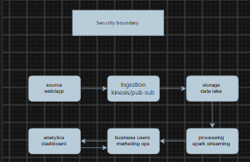

Guided Tool Module 2: Use Hadoop and Spark Documentation
Purpose: Decide whether your problem needs batch processing, streaming processing or hybrid processing by reading official Hadoop/Spark documentation.
No. | Perform |  | Observe / Decide |  | Record in Workbook
1 | Open the Apache Hadoop MapReduce tutorial. |  | MapReduce is suitable when large stored data can be processed in batches, such as daily logs or historical transactions. |  | Write one sentence on what mapper and reducer mean.
2 | Open the Apache Spark Structured Streaming guide. |  | Structured Streaming is suitable when new events continuously arrive, such as sensors, clickstream, live alerts or location updates. |  | Write one sentence on what streaming source, processing and sink mean.
3 | Classify your scenario data into batch data and streaming data. |  | Historical records normally become batch data; live sensor/log/API updates normally become streaming data. |  | Complete the batch-vs-stream table.
4 | Choose one processing approach for your scenario: Hadoop/MapReduce, Spark batch, Spark streaming or hybrid. |  | The decision must match the data velocity and decision urgency. |  | Write your processing decision.
5 | Prepare a simple pseudo-flow, not full code. |  | Example: Mapper reads log line -> emits hour, count. Reducer sums counts. Dashboard shows peak hour. |  | Write pseudo-flow or paste diagram.
Data Item |  | Batch / Streaming |  | Why |  | Suggested Framework
Clickstream events (page views, clicks) |  | Streaming |  | Needed in real time to detect cart abandonment and personalize recommendations immediately |  | Spark Structured Streaming
Cart add/remove events |  | Streaming |  | Time-sensitive — recovery emails lose effectiveness if delayed |  | Spark Structured Streaming
Payment transaction/failure events |  | Streaming |  | Failed payments need immediate detection to alert operations and prevent revenue loss |  | Spark Structured Streaming
Historical order/sales records |  | Batch |  | Used for daily/weekly reporting where same-day urgency isn't required |  | Hadoop MapReduce / Spark Batch
Campaign performance logs |  | Batch |  | Marketing reviews campaign ROI periodically, not instantly |  | Hadoop MapReduce / Spark Batch
Product catalog/inventory updates |  | Batch |  | Changes infrequently and doesn't need real-time processing |  | Hadoop MapReduce / Spark Batch

Processing Framework Decision
This scenario requires hybrid processing because e-commerce customer behavior data has two distinct urgency levels. Live clickstream events, cart additions, and payment-failure events need to be processed in real time using Spark Structured Streaming, since a cart-abandonment recovery email or a payment-failure alert loses most of its value if delayed by hours — it needs to reach the customer or the operations team within minutes of the event happening. Historical data such as completed orders, sales totals, and campaign performance logs don't need immediate action — these are better suited to batch processing using Hadoop or Spark batch jobs, since they are typically reviewed in daily or weekly reports rather than acted on instantly. Because both types of data exist in this scenario, a hybrid architecture that runs streaming and batch pipelines side by side is the most appropriate choice, rather than relying on only one processing model.

MapReduce / Spark Pseudo-Flow
Stream source reads clickstream event
→ filter events where action = "add_to_cart" AND no matching "purchase" event within 30 minutes
→ emit (user_id, product_id, abandoned_cart = true)
→ Dashboard/alert system flags user for recovery email
Mapper reads order log line → emits (product_category, sale_amount) Reducer sums sale_amount per category Dashboard displays daily revenue by category

Guided Tool Module 3: Threat Modeling with OWASP Threat Dragon / Microsoft Tool
Purpose: Identify privacy and security risks in the big-data solution before proposing controls.
Tool Choice
Use OWASP Threat Dragon if you need a web/desktop cross-platform threat modeling tool. Use Microsoft Threat Modeling Tool when a Windows system is available. The required evidence is the threat model diagram and threat-control table.
No. | Perform |  | Observe / Decide |  | Record in Workbook
1 | Open OWASP Threat Dragon or Microsoft Threat Modeling Tool. |  | A threat model is a security diagram that shows components, data flows, trust boundaries and possible threats. |  | Write which tool you used.
2 | Create a new threat model named with your scenario. |  | Use a clear title such as CO4_AT2_Healthcare_Emergency_Analytics. |  | Paste model name.
3 | Add external entities. |  | External entities are users/systems outside your platform: patient, customer, sensor, payment gateway, bus GPS device, public API. |  | List at least two external entities.
4 | Add processes and data stores. |  | Processes transform data; data stores hold data. Example: ingestion API, stream processor, data lake, warehouse, dashboard. |  | List processes and stores.
5 | Draw data flows and trust boundaries. |  | Trust boundaries mark where security assumptions change: public internet to cloud, app to API, processing layer to storage. |  | Paste screenshot of DFD.
6 | Identify threats using STRIDE thinking. |  | Spoofing, Tampering, Repudiation, Information Disclosure, Denial of Service and Elevation of Privilege help structure risks. |  | Complete the threat table.
7 | Write mitigations. |  | Controls may include authentication, authorization, encryption, masking, audit logs, rate limits, backup and monitoring. |  | Map every threat to one control.
Component / Data Flow |  | Threat |  | Impact |  | Mitigation
Ingestion API |  | Spoofing — fake/bot clickstream events sent to the API |  | Skewed analytics, false abandonment/conversion signals |  | API-key authentication and rate limiting
Customer → Payment Gateway flow |  | Tampering — payment data altered in transit |  | Financial loss, incorrect charges |  | TLS encryption end-to-end, integrity checks
Data Lake |  | Information Disclosure — unauthorized access to stored customer PII |  | Privacy breach, regulatory violation |  | Encryption at rest, field-level masking, access control
Stream Processor |  | Denial of Service — flooding the pipeline with junk events during a sale spike |  | Delayed alerts, missed cart-recovery windows |  | Auto-scaling ingestion, request throttling
Dashboard |  | Elevation of Privilege — a user viewing data beyond their role |  | Unauthorized access to customer-level data |  | Role-based access control (RBAC)
Recommendation Engine |  | Repudiation — no logging of who changed recommendation logic |  | Untraceable errors or manipulation |  | Audit logging of all configuration changes

Threat Model Diagram Evidence
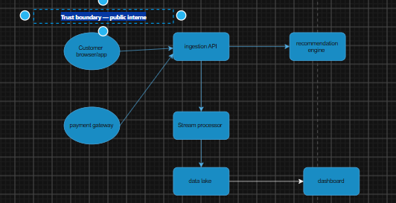

Guided Tool Module 4: Dashboard or Analytics Output Mockup
Purpose: Show how raw big data becomes useful decisions through a dashboard, alert, forecast, recommendation or report.
Beginner-Friendly Choice
Use any one: Power BI, Looker Studio, Tableau Public or Canva. If login/install is difficult, Canva dashboard mockup is acceptable. If data connection is possible, Power BI/Looker Studio/Tableau Public is stronger.
No. | Perform |  | Observe / Decide |  |  | Record in Workbook
1 | Prepare a small sample dataset in Excel or Google Sheets with 10-20 rows. |  | Columns should match your scenario. Example: timestamp, user/location, event type, value, status, risk level. |  |  | Paste column names.
2 | Choose the dashboard tool. |  | Power BI/Tableau/Looker are analytics tools; Canva is acceptable for visual mockup when live data connection is blocked. |  |  | Write chosen tool and reason.
3 | Import or recreate the sample data. |  | In Power BI/Looker/Tableau, connect data. In Canva, manually create charts from sample values. |  |  | Paste screenshot of data/chart setup.
4 | Create at least three visual elements. |  | Use KPI card, bar chart, line chart, table, map, alert count or pie/donut chart as appropriate. |  |  | List the visuals.
5 | Add decision labels. |  | A dashboard is useful only if it supports a decision: allocate beds, detect fraud, reroute buses, restock products, warn farmers. |  |  | Write decision supported by each visual.
6 | Export/share screenshot. |  | Paste the final dashboard screenshot or public/report link if available. |  |  | Paste evidence.
Dataset Column |  | Meaning |  |  | Example Value
timestamp |  | Date and time the event occurred |  |  | 2026-08-20 14:32:05
user_id |  | Unique identifier for the customer |  |  | U10456
event_type |  | Type of customer action performed |  |  | cart
product_id |  | Identifier for the product involved in the event |  |  | P2093
campaign_source |  | Marketing channel or campaign that brought the customer to the site |  |  | Instagram_Ad_Aug
cart_value |  | Monetary value of the cart at the time of the event |  |  | 1499.00
Visual Element |  | Metric Shown |  | Decision Supported
KPI Card |  | Cart Abandonment Rate |  | Whether to trigger recovery email campaigns
Bar Chart |  | Payment failures by method |  | Which payment method needs fixing/support
Line Chart |  | Traffic by campaign source over time |  | Where to reallocate marketing/ad spend

Dashboard / Analytics Output Evidence
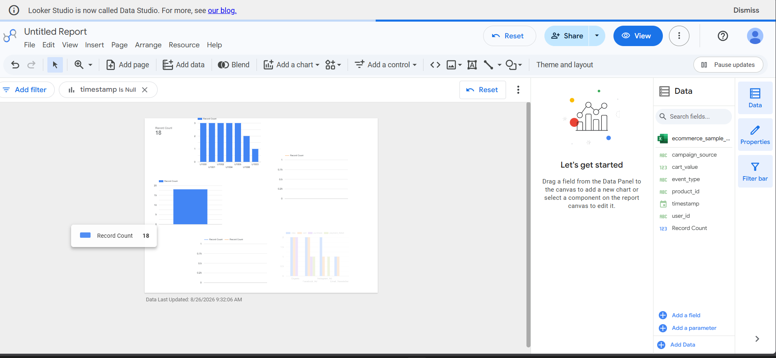

Final CO4 AT2 Solution Sections
Final Assembly
After completing the guided tool modules, combine the evidence into the final solution. The final answer must show technical reasoning, not only screenshots.

1. Problem Understanding
What to include: Identify stakeholders, decisions required, data produced, expected analytics output and urgency.

Student Response
Marketing and ops teams lack real-time visibility into customer drop-off. Stakeholders: marketing, operations, product teams. Key decisions: who to target with recovery emails, which payments are failing, which campaigns work. Output needed: near-real-time dashboard with cart-abandonment and payment-failure alerts. Urgency: high for fraud/cart signals, lower for campaign reports.

2. 5Vs Mapping
What to include: Map Volume, Velocity, Variety, Veracity and Value using scenario evidence.

Student Response
Volume: Millions of clickstream/transaction events daily. Velocity: Real-time clicks, cart, and payment events. Variety: Structured orders, semi-structured clickstream logs, campaign metadata. Veracity: Bot traffic and duplicate events need filtering. Value: Higher conversion via timely cart-recovery and fewer payment failures.

3. Big Data Architecture
What to include: Paste final draw.io architecture showing sources, ingestion, storage, processing, analytics/security and users.

Student Response
Sources → Ingestion (event streaming) → Data Lake → Processing (Spark batch + streaming) → Analytics/Security → Business Users, with encryption at ingestion and storage.

4. Data Flow Pipeline
What to include: Explain how raw data moves, gets cleaned, stored, processed and converted into dashboard/alert/decision.

Student Response
Raw events are ingested in real time, stored in a data lake, cleaned to remove bots/duplicates, then split into streaming (cart/payment alerts) and batch (daily reports) processing, finally reaching dashboards for marketing/ops decisions.
5. Tool and Technology Justification
Kinesis/Event Hubs/Pub-Sub for scalable ingestion; data lake for high-volume semi-structured storage; Spark Structured Streaming for real-time cart-abandonment detection; Hadoop/Spark batch for historical reports; Looker Studio/Power BI for dashboards.

What to include: Use cloud architecture references and Hadoop/Spark documentation to justify chosen tools.

Student Response
Type response / paste screenshot / paste diagram here.

6. Security and Privacy Strategy
What to include: Use threat model output to explain threats and controls.

Student Response
ey risks: spoofed events at ingestion, payment data tampering, PII exposure in the data lake. Mitigations: API-key auth and rate limiting, TLS encryption in transit, encryption at rest with data masking, and role-based access control.

7. Challenges and Solutions
What to include: Write at least four big-data implementation challenges and one practical solution for each.

Student Response
Bot traffic skews data → bot-filtering rules. 2. PII exposure → encryption + masking. 3. Late-arriving events → watermarking in Spark. 4. Traffic spikes → auto-scaling ingestion.

8. Business Outcome
What to include: State measurable outcome: faster decision, reduced fraud, lower waiting time, improved prediction, lower downtime or better user experience.

Student Response
Real-time detection of cart abandonment and payment failures enables faster recovery actions, reducing abandonment rate and improving conversion.

Rubric
Criteria | Marks | Evaluation Focus | Evidence
Problem and 5Vs analysis | 6 | Scenario-specific analysis and correct big-data reasoning | Workbook tables
Architecture and data flow | 6 | Correct pipeline, cloud components and flow clarity | draw.io diagram
Processing framework decision | 5 | Batch/streaming/hybrid justification using Hadoop/Spark concepts | Decision table
Security and privacy | 5 | Threat model, risks and controls | Threat model table/screenshot
Dashboard/output design | 4 | Useful decision-oriented analytics output | Dashboard/mockup
Clarity and submission quality | 4 | Organized, original, complete evidence | GitHub/GCR

Submission Checklist
- Student details and selected scenario are filled.
- Cloud architecture references are recorded.
- Hadoop/Spark processing decision is completed.
- Threat model diagram/table is included.
- Dashboard/mockup screenshot or link is included.
- Final solution sections are completed.
- DOCX/PDF and supporting files are uploaded to GitHub.
- GitHub repository link is submitted through Google Classroom.

Official Reference Links
AWS Architecture Center: https://aws.amazon.com/architecture/
Azure Architecture Center: https://learn.microsoft.com/en-us/azure/architecture/
Google Cloud Architecture Center: https://docs.cloud.google.com/architecture
Apache Hadoop MapReduce Tutorial: https://hadoop.apache.org/docs/stable/hadoop-mapreduce-client/hadoop-mapreduce-client-core/MapReduceTutorial.html
Apache Spark Structured Streaming: https://spark.apache.org/docs/latest/streaming/index.html
Microsoft Threat Modeling Tool releases: https://learn.microsoft.com/en-us/azure/security/develop/threat-modeling-tool-releases
OWASP Threat Dragon: https://owasp.org/www-project-threat-dragon/
Power BI documentation: https://learn.microsoft.com/en-us/power-bi/
Looker Studio create report: https://docs.cloud.google.com/data-studio/create-a-report
Tableau Public: https://www.tableau.com/community/public
Canva Charts: https://www.canva.com/help/charts/

